School of St. Mary
Summer Reading Project
Entering 3rd Grade

This summer, please read and complete:
-One book of your choice (that you haven’t previously read) from the attached list.
-Complete the attached summary sheet on the novel.
-Assemble a basket of 6-8 items that represent your book along with an explanation of each item on index cards.

Free Choice Book List:
The reading level indicates the approximate reading level in school years. For example, a 3.0 would mean in the beginning of 3rd grade. Base your child’s appropriate reading level on his/her Accelerated Reading level.
Ivy and Bean Make The Rules By: Annie Barrows
Genre: Fiction/Humor (530L/3.4)
Ivy and Bean are best friends and do everything together. In the ninth book in the series, Ivy and Bean look for adventure when they can’t go to summer camp. They find it when they make up their own camp! They become counselors, and bring a whole new meaning to arts and crafts.
Freckle Juice By: Judy Blume
Genre: Fiction/Humor (570L/3.6)
Andrew Marcus wants freckles more than anything in the world. His classmate has freckles, so he buys a friend’s secret freckle recipe for fifty cents. But what starts as a simple freckle recipe turns into disaster. Andrew thinks he has the perfect solution, or does he?
Frindle By: Andrew Clements
Genre: Realistic Fiction (830L/4.0)
When clever yet precocious Nick decides to invent a new word for ‘pen,’ it puts him at odds with his no-nonsense teacher who is a stickler for grammar. What begins as a classroom duel over the usage of the word “frindle” escalates into a national word craze.

Judy Moody Was In A Mood By: Megan McDonald
Genre: Fiction/Humor (530L/3.4)
Judy doesn’t have high hopes for third grade, and she is in a bad mood about it! But, when her teacher assigns a special project, Judy will finally get to express herself!
Stink: The Incredible Shrinking Kid By: Megan McDonald
Genre: Realistic Fiction (540L/3.5)
Stink is the little brother of Judy Moody, another fantastic series! Judy always measures Stink, who always measures the same height: three feet, eight inches. Then one day, Judy measures him as three feet, seven and three quarter inches. Is Stink shrinking?
Big Nate Out Loud By: Lincoln Peirce
Genre: Graphic Novel (300L/2.5)
Big Nate, aka Nate Wright, is 11 years old. His friends won’t let him be the lead singer in the band, but he won’t let that stop him from ‘rocking out.’
Henry and Mudge: The First Book By: Cynthia Rylant
Genre: Fiction/Humor (460L/3.3)
The first in a series of books, Henry finds himself lonely on a street without any other children. He finds a friend, and love, in a big dog named Mudge.
Third Grade Angels By: Jerry Spinelli
Genre: Realistic Fiction (390L/3.0)
George ‘Suds’ Morton competes with his third-grade classmates to earn the first ‘halo’ of the year for good behavior. However, being ‘good’ turns out to be more stressful than he anticipated.
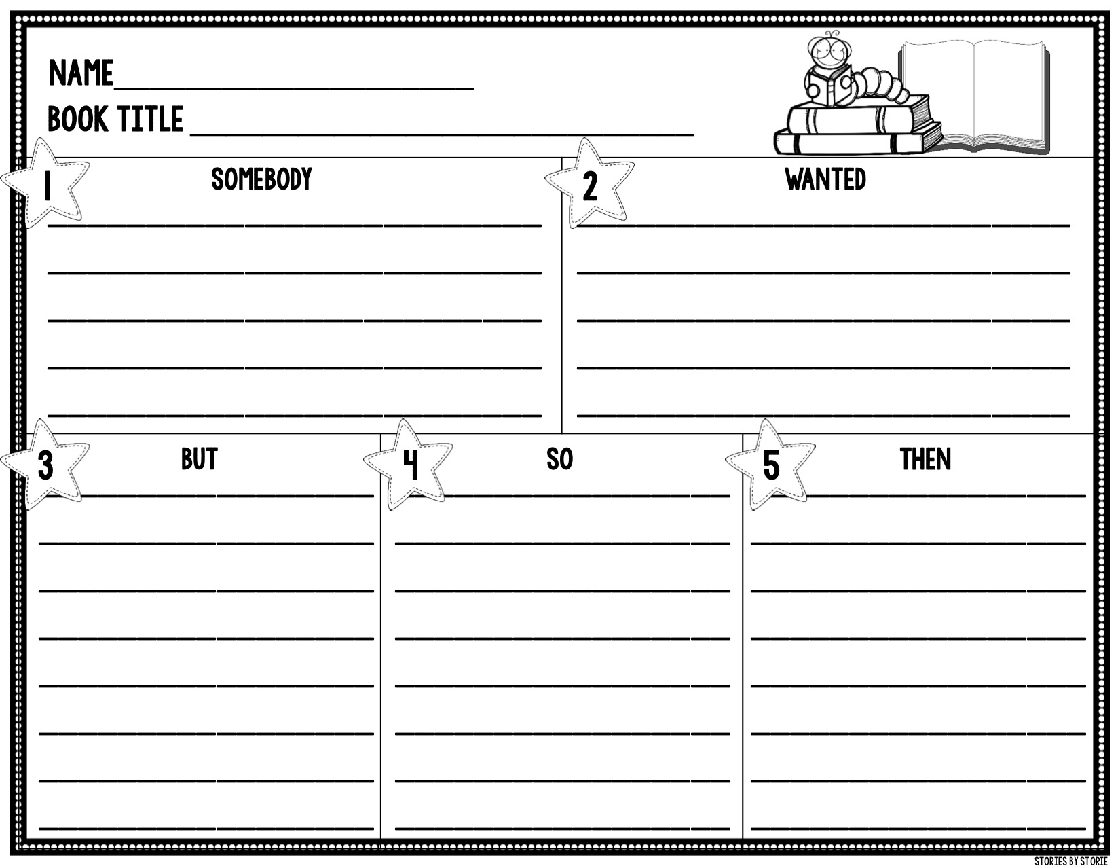
After completing your required reading,
You are welcome to read any of the following:

- Adventures of a South Pole Pig by Chris Kurtz
- Alvin Ho by Lenore Look (series)
- Creature Features: 25 Animals Explain Why They Look the Way They Do by Steve Jenkins
- Discovering Dinosaurs by Daniel Cohen (series)
- Eye to Eye: How Animals See the World by Steve Jenkins
- Finding Winnie: True Story of the World’s Most Famous Bear by Lindsay Mattick
- Geronimo Stilton by Geronimo Stilton (series)
- Gooney Bird Greene by Lois Lowry
- Gooseberry Park by Cyntha Rylant
- Ivy & Bean by Annie Barrows (series)
- Joe Sherlock Kid Detective by Dave Keans
- Littles by Josh Peterson (series)
- Magic Tree House by Mary Pope Osborne and Sal Murdocca (series)
- Marty McGuire by Kate Messner (series)
- Matt Christopher Sports by Matt Christopher (series)
- Melvin Beederman Superhero by Greg Trine and Rhode Montijo (series)

- Mouse on a Motorcycle by Beverly Cleary
- My Weird School by Dan Gutman (series)
- Nims Island by Wendy Orr
- Non-Fiction animal books by Nic Bishop (series)
- One Small Dog by Johanna Hurwitz
- Pee Wee by Johanna Hurwiz (series)
- Princess in Black by Shannon Hale (series)
- Rainbow Magic by Daisy Meadows (series)
- Ramona by Beverly Cleary
- The Lighthouse Family: The Storm by Cynthia Rylant (series)
- The Truth of Me by Patricia macLachlan
- Tales of Buhnjitso Bunny by John Mimmelman
- Third Grade Baby by Jenny Meyerhoff and Jill Weber
- Toys Go Out by Emily Jenkins
- Twelve Dancing Unicorns by Alyssa Heyman
- Whatever After by Sara Mlynowski (series)
- Wiley and Grandpa by Kirk Scroggs

