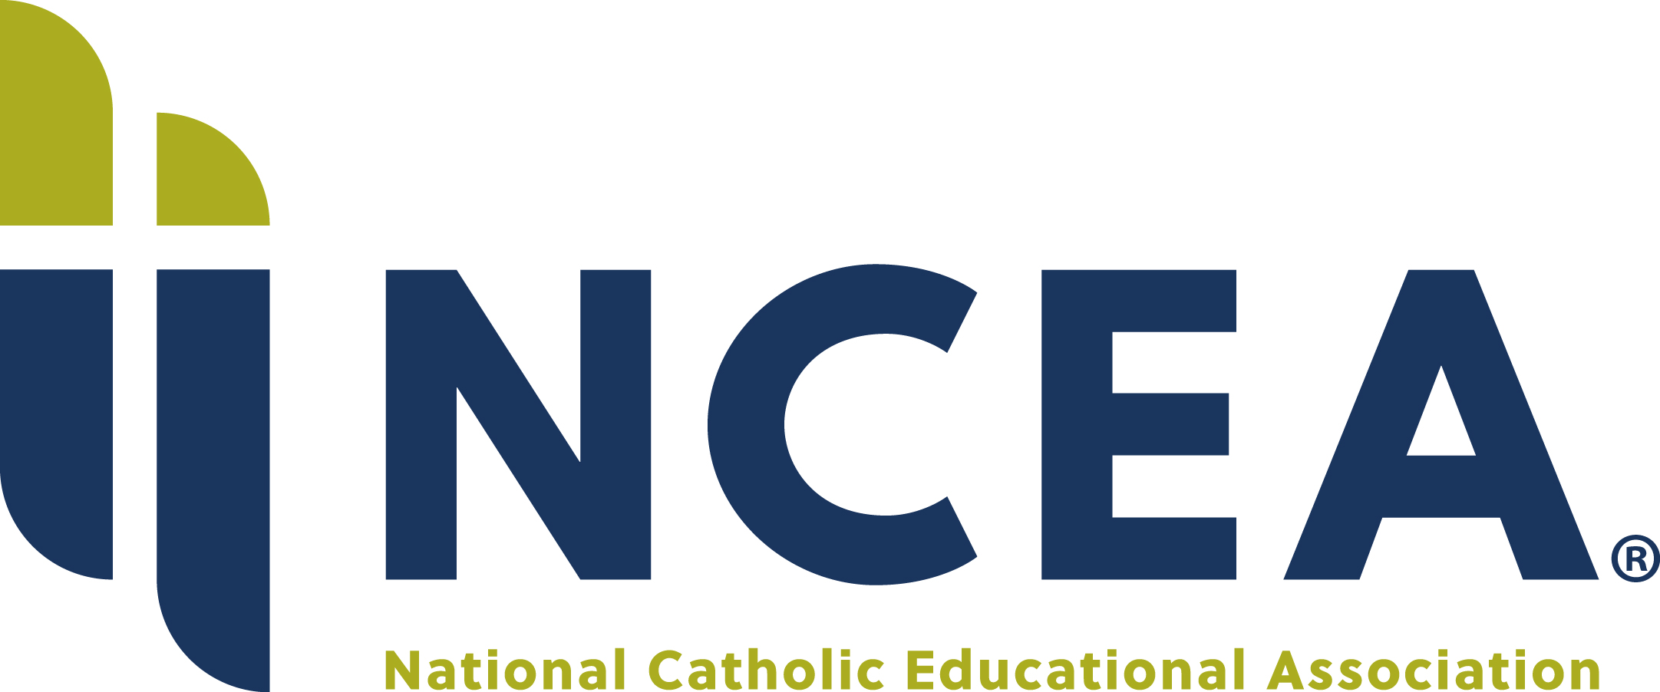

Press release

For immediate release
Date April 4, 2022

Contact Margaret Kaplow, Public Relations Manager
National Catholic Educational Association
mkaplow@ncea.org
800.711.6232

RELEASE Margaret Kaplow, Public Relations Manager
National Catholic Educational Association
mkaplow@ncea.org
800.711.6232

RELEASE NATIONAL CATHOLIC EDUCATIONAL ASSOCIATION ANNOUNCES 13 HONOREES FOR THE 2022 LEAD. LEARN. PROCLAIM. AWARDS
Outstanding leaders in Catholic school education to be honored on April 18, 2022, at the NCEA 2022 Convention in New Orleans

Leesburg, VA – The National Catholic Educational Association (NCEA) announces 13 recipients of the 2022 Lead. Learn. Proclaim. Awards (LLP), which highlight the outstanding work of Catholic school educators in communities across the country. Catholic school leaders, teachers, principals and presidents, pastors, diocesan superintendents, school boards and home school associations are among the troupe of exceptional awardees entrusted with the faith formation in our communities of Catholic school education.

“NCEA commends the extraordinary efforts, contributions and achievements of these exceptional leaders in Catholic education,” said Lincoln Snyder, NCEA President/CEO. “They are recognized as ambassadors of faith formation and academic excellence imparting the fullness of the Church’s faith for all of us working in Catholic school education.”

NCEA will recognize the 13 honorees of the 2022 Lead. Learn. Proclaim. Awards at the NCEA 2022 Convention at an awards dinner that will take place on Monday, April 18, at the Hilton New Orleans Riverside.

The awardees being honored are: Karen Alestock, Father Randy Cuevas, Reverend Stephen Dudek, Michael Goldsmith, Kimberly Hermsen, Ed.S., Maureen Marsteller, Ph.D., Sister Eileen McGowan, D.M., Denise McMonagle, Sondra Morris, Leticia Oseguera, David Palmieri and Sister Thomasann Quinn and Kathy Thompson.

Please view the list of the 2022 LLP Award recipients on the NCEA website.

NCEA’s 2022 Convention is the largest private-education association gathering in the nation. The annual convention draws thousands of participants from Catholic school communities including elementary and secondary school teachers and principals, religious education programs as well as diocesan offices, church pastors, superintendents, school boards. The convention is a forum to exchange ideas, hear about current research and data related to Catholic school education and learn about new technology and resources from NCEA partners, sponsors and exhibitors.

This year, the NCEA 2022 Convention will be hosted by the Archdiocese of New Orleans, April 19 – 21 at the Hilton New Orleans Riverside. For more information, visit: www.ncea.org/convention.

For more information on NCEA, visit www.NCEA.org and connect with NCEA on YouTube, LinkedIn, Facebook and Twitter.

###

In service of the Gospel of Jesus Christ, NCEA strengthens Catholic school communities by providing professional development, formation, leadership and advocacy.

