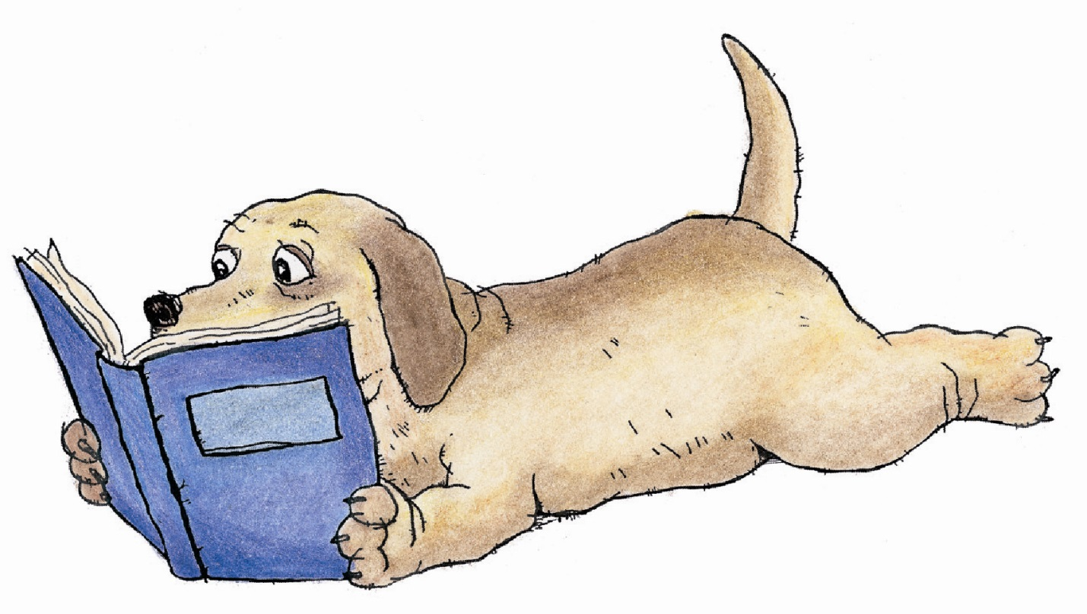
Preschool Students Moving to Kindergarten Summer Reading List
Every four-year-old student moving to kindergarten needs to read:
Mother Goose Favorites by Tomie dePaola
Additional suggestions: (Since most preschool children cannot read, the following suggestions are great books to read aloud to children. It is good to read rhyming books to these emerging readers.)

- All in a Day by Cynthia Rylant
- Alphabet Under Construction by Denise Fleming
- Anno’s Counting Book by Mitsumasa Anno
- Bats at the Library by Brian Lies
- Birds by Kevin Henkes
- Cat & Mouse by Ian Schoenherr
- Child’s Good Morning Book by
Margaret Wise Brown
- Chicken Little by Rebecca Emberley
- Corduroy by Don Freedman
- Countdown to Kindergarten by Alison McGhee
- Dumpy the Dump Truck Julie Andrews Edwards
- Frederick by Leo Leonni
- Funny Farm by Mark Teague
- Hi, Koo! A Year of Seasons by Jon J. Muth
- House in the Night by Susan Marie Swanson
- How Are You Peeling? Foods with Moods by Saxton Freymann and Joost Elffers
- If You Plant a Seed by Kadir Nelson
- Interrupting Chicken by David Ezra Stein
- Knuffle Bunny Too by Mo Williams
- Library Mouse: A Friend’s Tale by Daniel Kirk
- Little Cloud by Eric Carl
- Look! Another Book! By Bob Staake
- Miranda’s Beach Day by Holly Keller
- Moonshot: The Flight of Apollo 11
by Brian Floca
- Posy by Linda Newbery
- Rise and Shine! by Tim Warnes
- Shark vs. Train by Chris Barton
- Swimmy by Leo Leonni
- The Alphabet Tree by Leo Leonni
- The Snowy Day by Ezra Jack Keats
- This is a Firefighter by Laura Godwin
- You Can Do It by Tony Dungy
- You Never Heard of Sandy Koufax?
by Jonah Winter
- Waiting by Kevin Henkes
- Waiting for Wings by Lois Ehlert
- Wemberly Worried by Kevin Henkes
- What Do People Do All Day? by Richard Scarry

