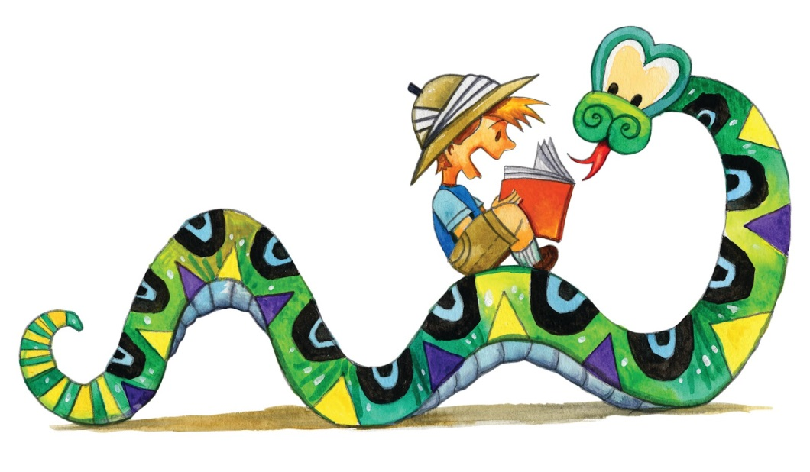
Kindergarten Students Moving to First Grade Summer Reading List
Every kindergarten student moving to first grade needs to read:

Chrysanthemum by Kevin Henkes

- Additional suggestions (Note that books with repetitive text make wonderful choices for children beginning to show an interest in reading):
  - A Ball for Daisy by Chris Raschka
  - Across the Stream by Mirra Ginsburg
  - Ask Mr. Bear by Marjorie Flack
  - Berenstain Bears series by Stan Berenstain
  - The Little Red Hen by Paul Galdone
  - Biscuit series by Alyssa Satin
  - Extra yarn by Mac Barnett
  - Franklin series by Paulette Bourgeois
  - George Washington’s Cows by David Small
  - Henry and Mudge series by Cynthia Rylant
  - Miss Smith’s Incredible Story Book by Michael Garland
  - Little Cliff’s First Day of School by Clifton Taubert
  - Olivia series by Ian Falconer
  - Pete the Cat series by Eric Litwin and Dean James
  - Quick as a Cricket by Audrey Wood
  - The Big Bug Surprise by Julia Gran
  - The Listening Walk by Paul Showers
  - The True Story of the Three Little Pigs by Jon Scleszka
  - You Read to Me, I’ll Read to You: Very Short Fairy Tales to Read Together by Mary Ann Hoberman
  - Wednesday by Anne Bertier

